ST. XAVIER’S COLLEGE

**Maitighar,Kathmandu**

**(Affiliated to Tribhuvan University)**



**Computer Graphics**

**Lab Assignment #1**

**Submitted By**

Ajita Khatiwada

B.Sc. CSIT

Year II/IV Semester

013BSCIT004

**Submitted To:**

Er. Anil Kumar Sah

Lecturer,

Department of Computer Science

St. Xavier’s College

Maitighar, Kathmandu

**Submitted On:**

7th August , 2015

**Statement:**

To design a simple calculator .

Source codes :

//---------------------------------------------------------------------------

#include <vcl\vcl.h>

#pragma hdrstop

#include "calc12.h"

//---------------------------------------------------------------------------

#pragma resource "*.dfm"

TForm1 *Form1;

int oper,x,y,z=0,val=0,flag=0;

//---------------------------------------------------------------------------

__fastcall TForm1::TForm1(TComponent* Owner)

: TForm(Owner)

{

}

void check(val)

{

if(flag==0)

{

x=val;

}

else

{

y=val;

}

}

//---------------------------------------------------------------------------

void __fastcall TForm1::Button1Click(TObject *Sender)

{

val=7;

flag=1;

check();

Edit1->Text=val;

}

//---------------------------------------------------------------------------

void __fastcall TForm1::Button2Click(TObject *Sender)

{

val=8; flag=1;

check();

Edit1->Text=val;

}

//---------------------------------------------------------------------------

void __fastcall TForm1::Button3Click(TObject *Sender)

{

val=9; flag=1;

check();

Edit1->Text=val;

}

//---------------------------------------------------------------------------

void __fastcall TForm1::Button5Click(TObject *Sender)

{

val=4; flag=1;

check();

Edit1->Text=val;

}

//---------------------------------------------------------------------------

void __fastcall TForm1::Button6Click(TObject *Sender)

{

val=5; flag=1;

check();

Edit1->Text=val;

}

//---------------------------------------------------------------------------

void __fastcall TForm1::Button7Click(TObject *Sender)

{

val=6; flag=1;

check();

Edit1->Text=val;

}

//---------------------------------------------------------------------------

void __fastcall TForm1::Button9Click(TObject *Sender)

{

val=1; flag=1;

check();

Edit1->Text=val;

}

//---------------------------------------------------------------------------

void __fastcall TForm1::Button10Click(TObject *Sender)

{

val=2; flag=1;

check();

Edit1->Text=val;

}

//---------------------------------------------------------------------------

void __fastcall TForm1::Button11Click(TObject *Sender)

{

val=3; flag=1;

check();

Edit1->Text=val;

}

//---------------------------------------------------------------------------

void __fastcall TForm1::Button13Click(TObject *Sender)

{

val=0; flag=1;

check();

Edit1->Text=val;

}

//---------------------------------------------------------------------------

void __fastcall TForm1::Button15Click(TObject *Sender)

{

switch(oper)

{

case 1:

{

z=x+y;

break;

}

case 2:

{

z=x-y;

break;

}

case 3:

{

z=x*y;

break;

}

case 4:

{

z=x/y;

break;

}

}

Edit1->Text=z;

}

//---------------------------------------------------------------------------

void __fastcall TForm1::Button4Click(TObject *Sender)

{

Edit1->Text="/";

oper=4;

}

//---------------------------------------------------------------------------

void __fastcall TForm1::Button8Click(TObject *Sender)

{

Edit1->Text="*";

oper=3;

}

//---------------------------------------------------------------------------

void __fastcall TForm1::Button12Click(TObject *Sender)

{

Edit1->Text="-";

oper=2;

}

//---------------------------------------------------------------------------

void __fastcall TForm1::Button16Click(TObject *Sender)

{

oper=1;

}

//---------------------------------------------------------------------------

**Output :**

General overview of calculator.

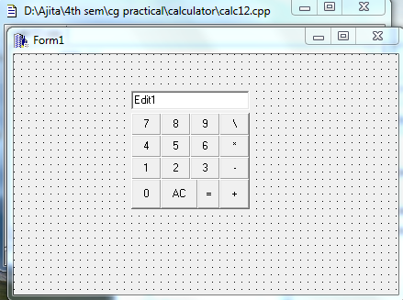

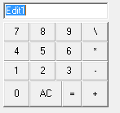

Multiplication operation

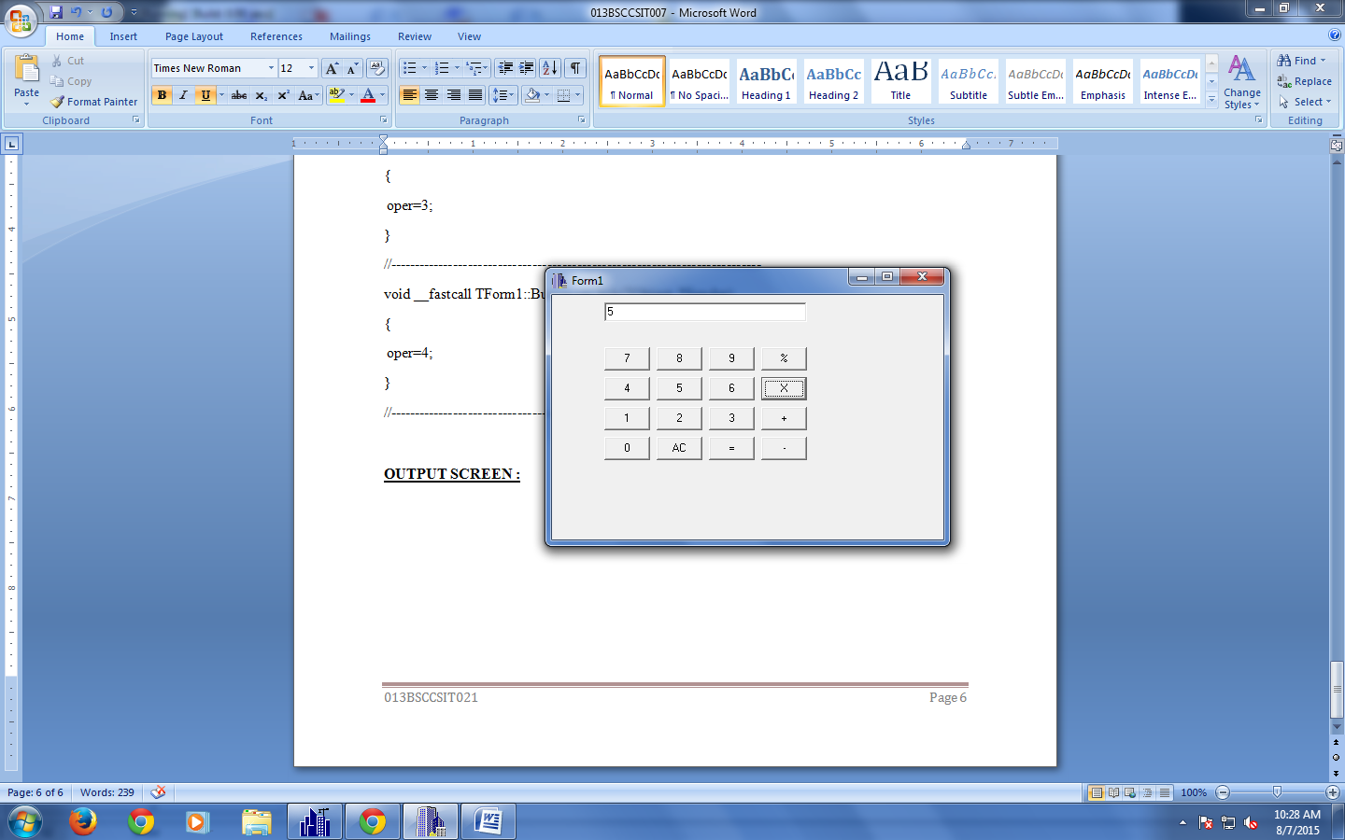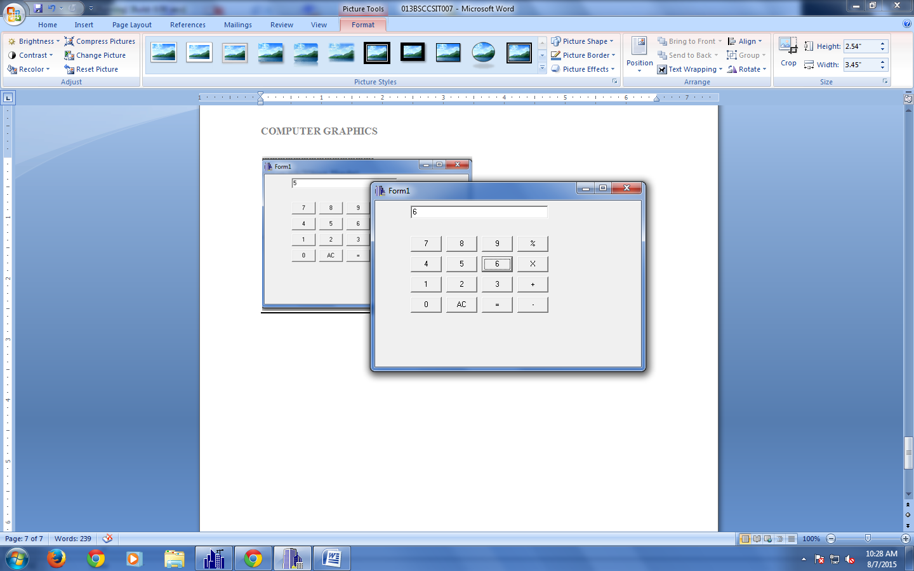

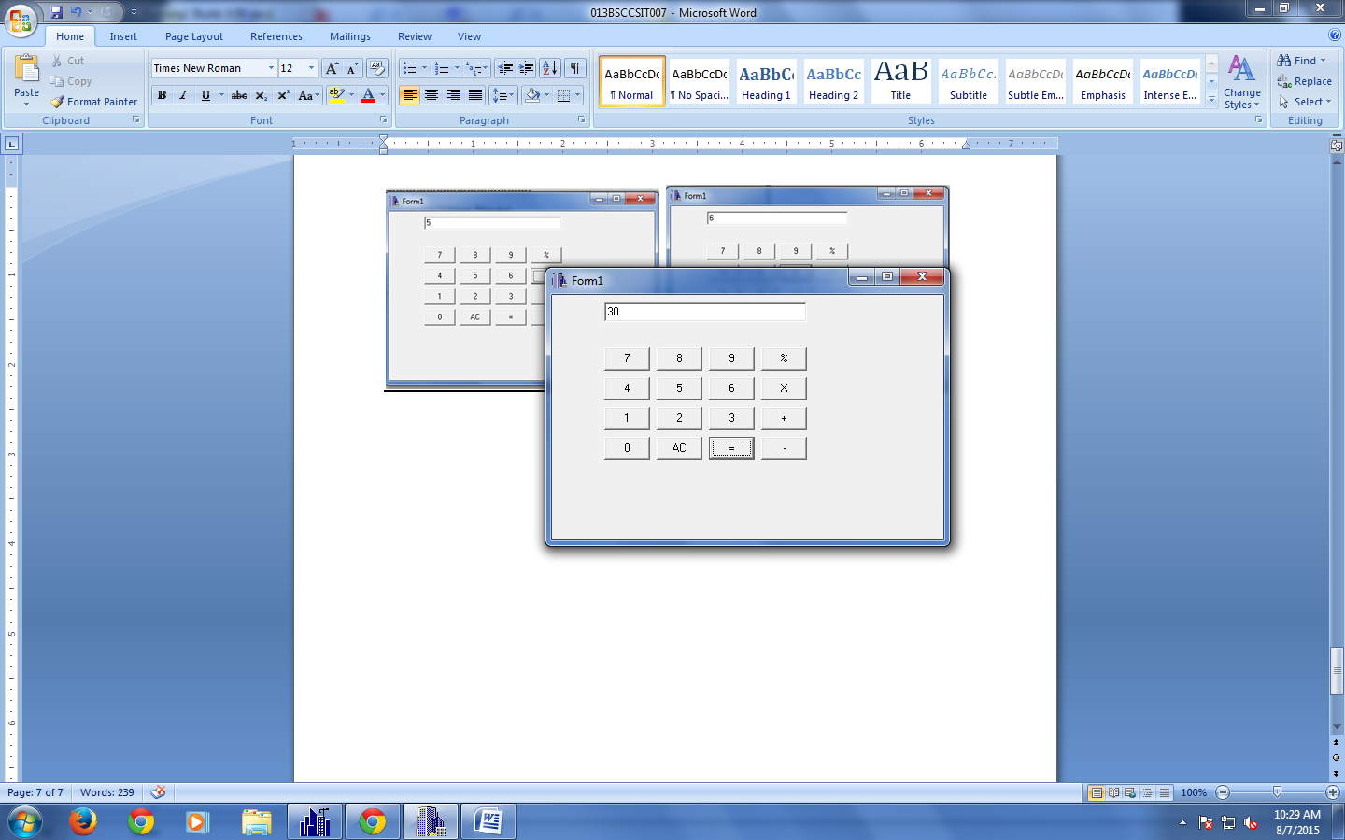

**Conclusion :**

Thus ,simple calculator was successfully designed using the c++builder. The calculator is a simple kind and cannot perform operations for the multi-digit numbers.